

77 Club

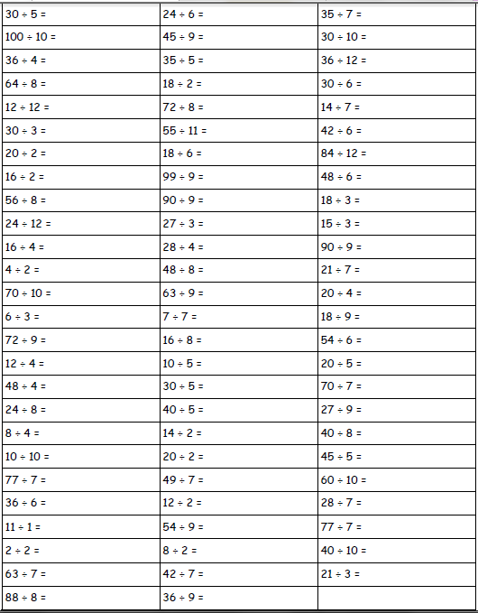Name:___________________ Date:________