

55 Club

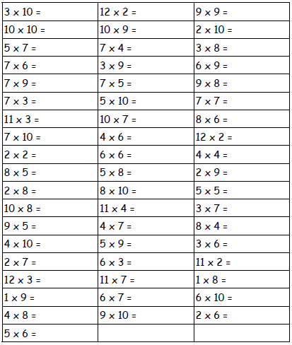Name:___________________