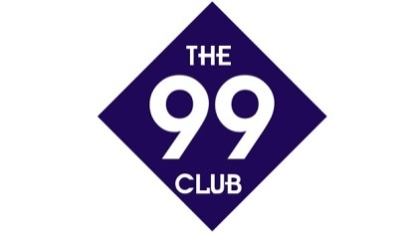

44 Club

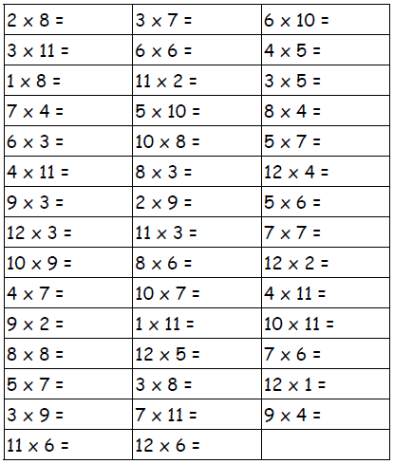Name:_____________